Project Plan

<Project Name>

Student Names

Table of Contents

1.0 Introduction 3

1.1 Problem Background 3

1.2 Scope 3

1.3 Document contents 3

2.0 Work Breakdown Structure 4

3.0 Activity Definition & Estimation 5

4.0 Gantt Chart 6

# Introduction

## Background

## Scope

## Document contents

*Include some background information about the problem, the scope and what this document will contain.*

# Work Breakdown Structure

*This section should include the work breakdown structure for the whole project. The elements from the WBS should be used to generate your activity definition and those activities should then be scheduled in the Gantt Chart. Remember to consider ALL project activities – anything you do or will need to do should be included in the WBS*

*WBS’s are usually presented as some kind of hierarchical diagram/chart etc. The details what is involved each work unit should be provided in section 3:* ***Activity Definition***

*You do NOT need to do a WBS Dictionary for this project – the activity definition (whilst slightly different) will suffice. The WBS is focussed on SCOPE. The Activity definition is focussed on TIME.*

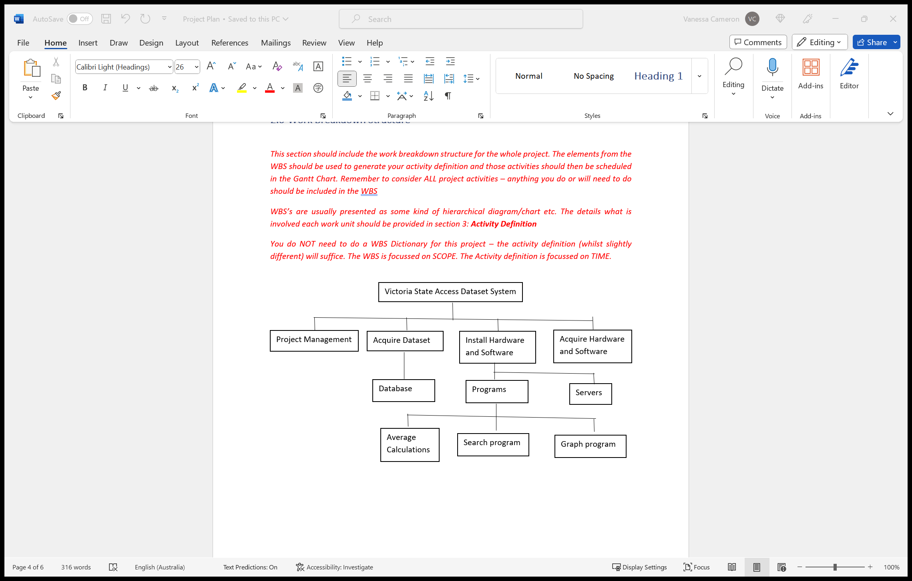

# Activity Definition & Estimation

*From your WBS, define the activities required for your project. You will revise this document and add more detail for part B as you discover more about the project.*

*Each activity should be clearly identified by a number and should match up to your Gantt chart. You should provide some estimations for the time you think each activity will take. This should make it easy to prepare your Gantt chart.*

1. Documentation acquired – 1 day.
2. Project Approved – 1 day – 1.
3. Team introduction and meeting – 1 day – 2.
4. Data collected – 1 day – 2,3.
5. Server for database set up – 1 day – 4.
6. Programs set up – 3 days – 5.
7. Testing phase – 1 day – 6
8. Presenting database for approval – 1 day - 7

# Gantt Chart

*This section should contain your Gantt chart. The items in the Gantt chart should match the activity definition from section 3. You should also submit your Gantt chart file separately.*

